USB RNDIS CM4

- CM4:
- Turn on Ethernet Slave:
+ [sudo nano /boot/firmware/config.txt], Add these lines (UART3 for OBC-STM32)
modules-load=dwc2,g_ether
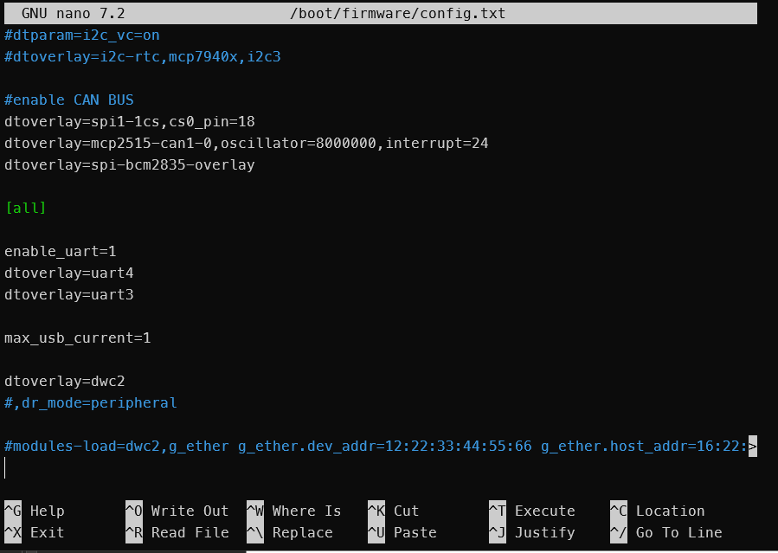
+ At [sudo nano /boot/firmware/cmdline.txt], add this line right after “rootwait”
modules-load=dwc2,g_ether

- Create dhcpcd:
+ sudo apt install dhcpcd
+ sudo nano /etc/dhcpcd.conf Set static ip USB
interface usb0
static ip_address=[ip]/nm
+ sudo systemctl enable dhcpcd
+ reboot
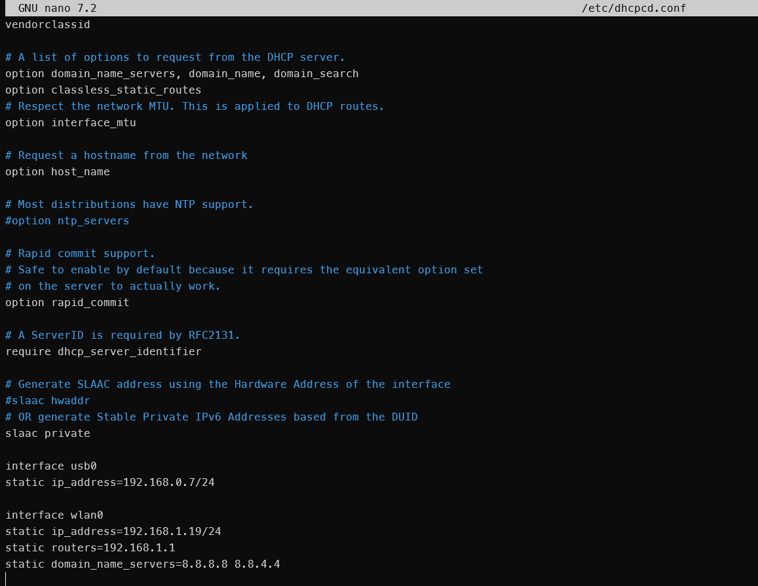

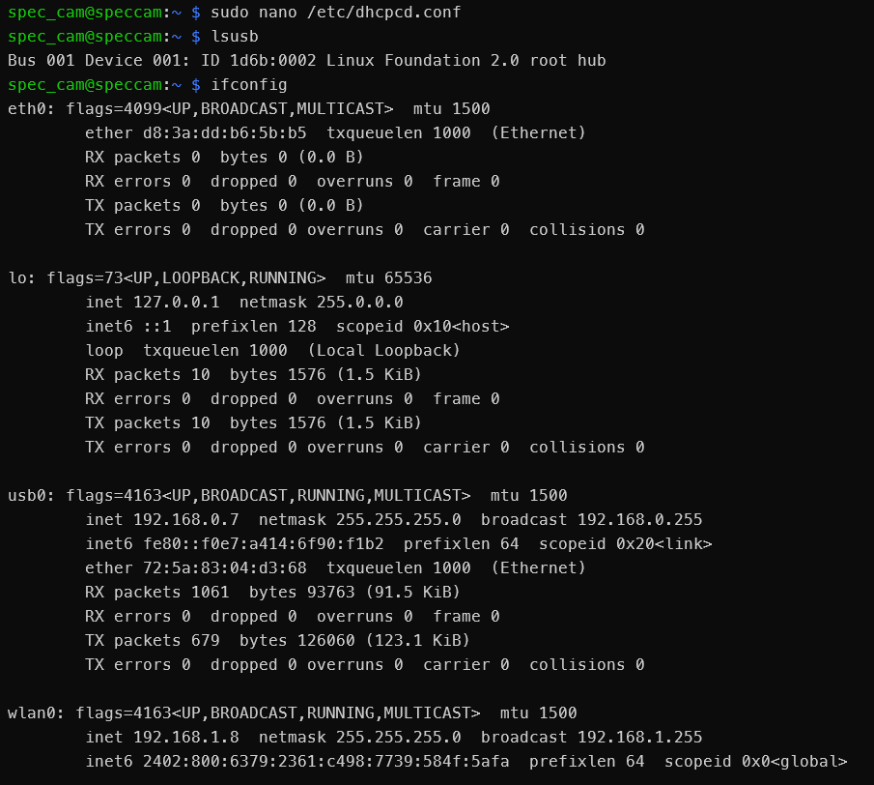
- Host connect

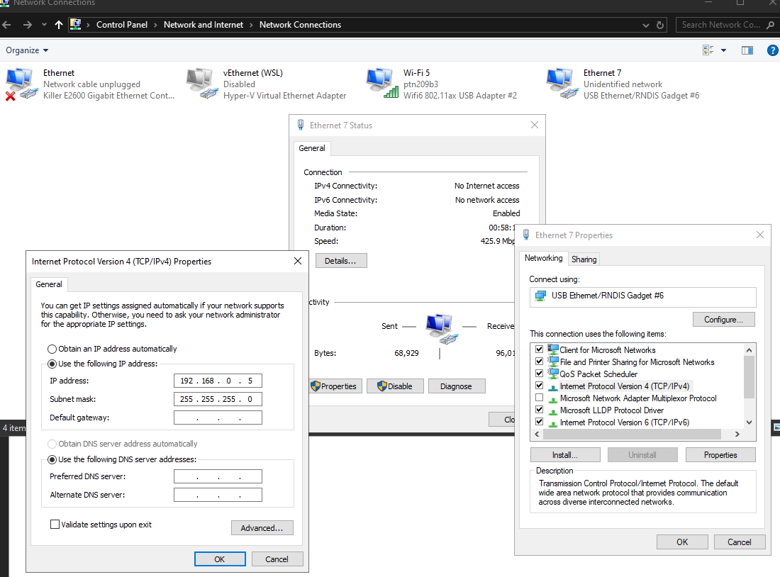

- Window: After plugged-in USB, must install driver RNDIS:
Following this link to install: https://www.youtube.com/watch?v=bDZ7P7VzQWE
- Linux: Nothing to do. Set: netmask/gateway (usb slave 192.168.0.7):
Host: Sudo ifconfig usb0 192.168.0.5 netmask 255.255.255.0 up

